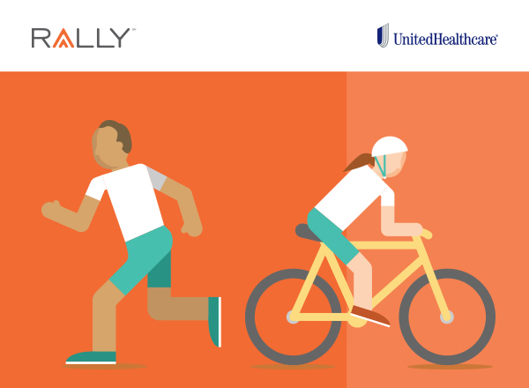
Achieving our health goals is a journey, and sometimes it’s not easy. That’s why we are thrilled to introduce Rally℠, a UnitedHealthcare® digital health and wellness experience.
Rally can help you make simple changes to your daily routine, set smart goals and stay on target. After completing a quick and fun survey, you’ll get personalized recommendations to get you moving more, eating better, feeling happier — and you’ll have fun doing it.
As a member of UnitedHealthcare, you have access to Rally at no additional cost.
How Rally can help you:
• | Discover your Rally Age — a way for you to measure your health
• | Get personalized health tips
• | Earn chances to win rewards for taking healthy actions
• | Get full access to your personal health records

Enjoy all the benefits of Rally today. Get started at myuhc.com.

